Admin Functionalities:

1. Admin can approve/reject update details request

Normal User Functionalities:

1. Change Password
2. Forgot Password
3. User can request to update credentials.
4. User can view the days left for the book to be returned.
5. Can view the fine imposed if any for late returning the book.
6. If possible integrate payment gateway to pay the fine.

Librarian User Functionalities:

1. Change Password
2. Forgot Password
3. View and Collect the fine for late returning the books.
4. Collect the fine charged if the book gets lost.
5. Send a reminder to each student account if it is the last date to return the book.

View Pages:

Admin Home Page:

1. View users according to category

Normal User Home Page:

1. Display all the books available in library by type or randomly.
2. Update credentials page.
3. Cancel booking for the book.
4. Display the books user borrowed along with days left or fine if any.
5. Option to see reminder notifications.
6. Change and Forgot Password Page

Librarian User Home Page:

1. Option to send reminder to the students whose last date is the current date.
2. Change and Forgot Password Page

Librarian Return Book Page:

1. If there is some fine then include the fine field as well and collect the fine.

Future Changes:

1. Can include email support for credentials change.
2. Can include phone number login through OTP.
3. Integrate Third party REST Api to fetch book details by author, ISBN etc

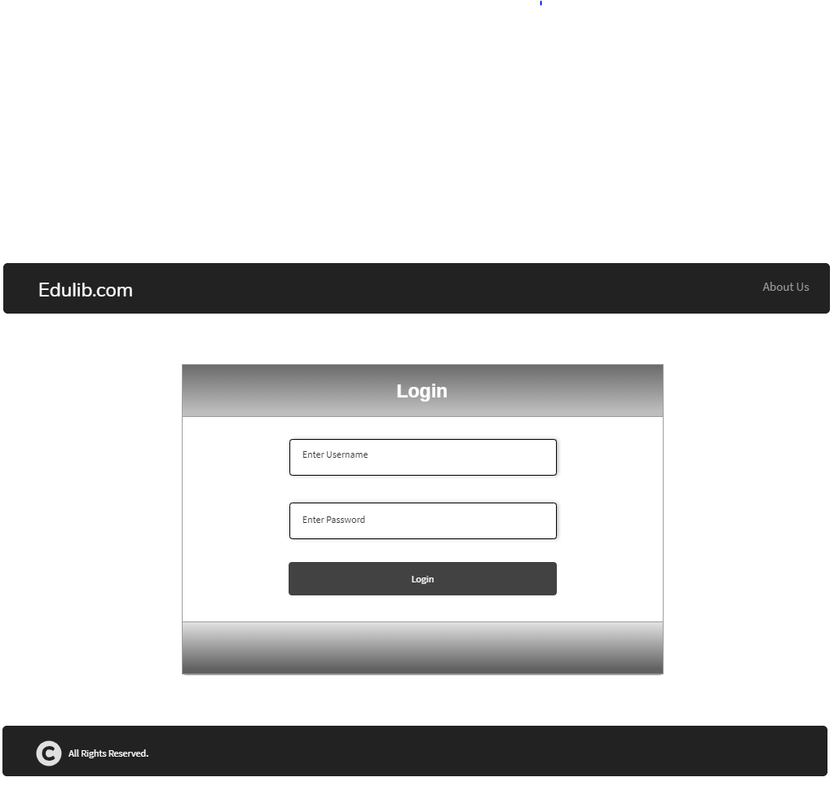

Common Login Page

User Pages

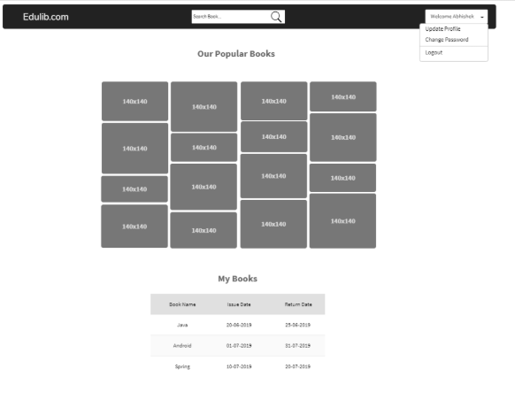

Normal User HomePage

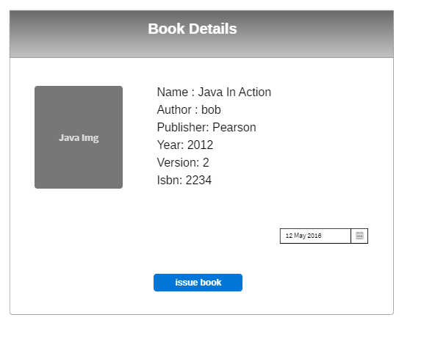

Request Book Page

Librarian Pages

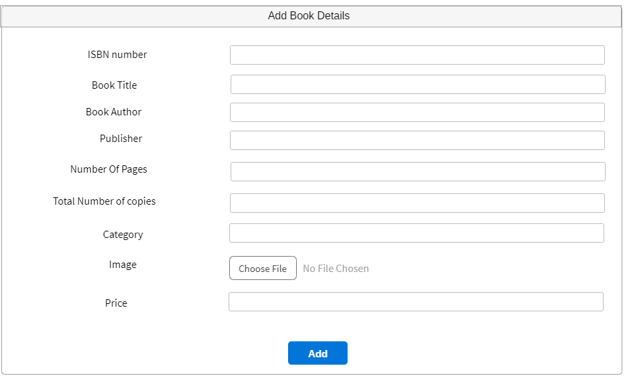

Add a new Book to Library

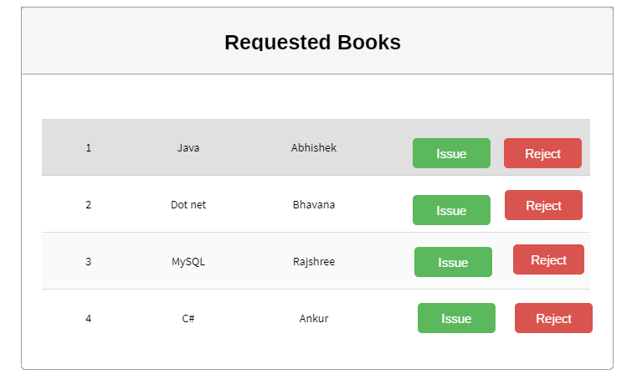

Book Request approval page

Admin Pages

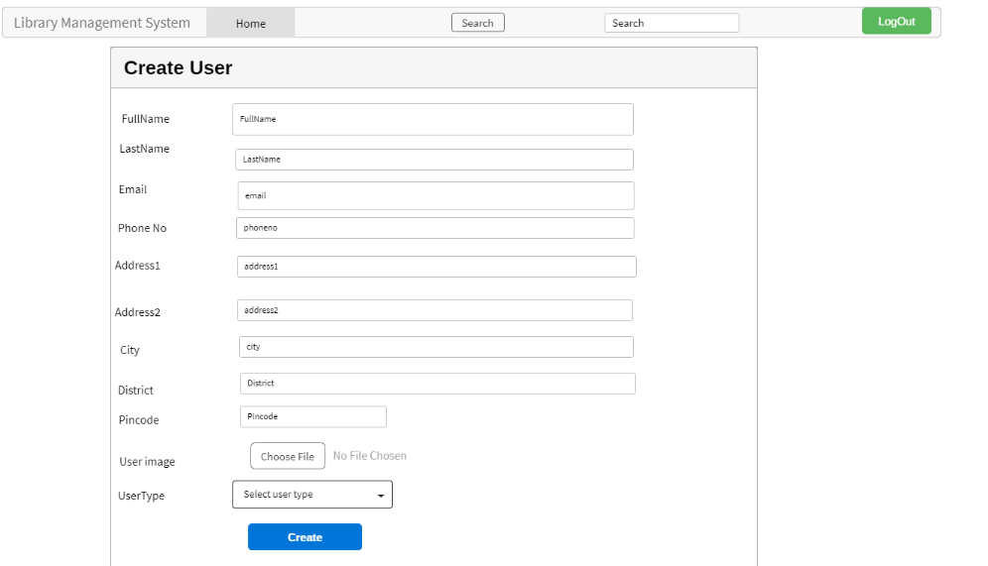

Create User Page

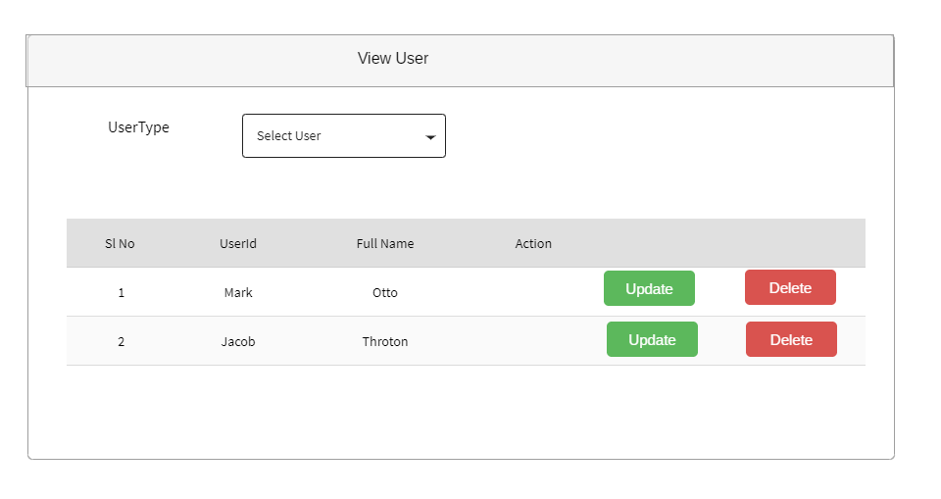

View Users